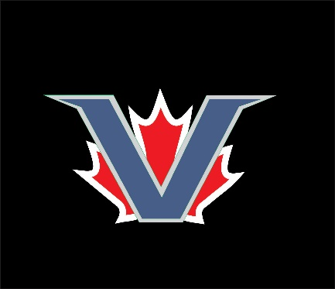

2018 SPRING-SUMMER BASEBALL
AGES 13-16

- FUN competitive baseball
- Experienced coaching
- FREE training by ex-college players (up to 7.5 hrs)
- Registration fee of $150 to play 11 weeks
- Practice twice a week
- Play 1-2 games per week
- Local tournaments
Spring baseball (April – mid June)
- all our kids (regardless of ability) play together. That’s right everyone learns to play together because we build kids and communities first.
- we play local teams from the island and Vancouver area. Did you know for the past 2 years we picked them up from the ferry, held a FREE
meal for players, coaches, parents and siblings, then took them back to the ferry. Now that’s fun community baseball!

Tournament baseball (June – July/August)
- assessments are done for those wishing to play tournament baseball.
- our Victoria teams receive an automatic bye into Provincials.
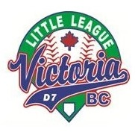
- if the team wins at Provincials there is a Canadian Championship and World Series for each age group.

Little League Victoria offers programs for ages 13-16 in three age groups:
- 11-13 yr olds – Intermediate – 50’ pitch, 70’ base path, full leadoffs and stealing
- 12-14 yr olds – Junior – 54’ pitch, 80’ base path, full leadoffs and stealing
- 14-16 yr olds – Senior – 60.5’ pitch, 90’ base path, full leadoffs and stealing

Contact your local Little League Park to register!

For more information contact Moe at president@cslittleleague.com or 250-886-6323

